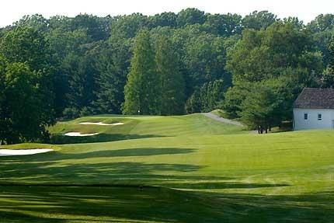

The Deerfield Golf Academy is pleased to provide the region’s most well-known and respected golf instructors to guide you toward having more fun and becoming a better player. Whether it’s an individual lesson, a series of lessons, a specialty camp or a group clinic, Director of Instruction Ryan Kempski will design a program of instruction that suits your needs.

Private Instruction Rates
Private Lesson: $115 per hour / $65 per half hour
Passholder Rate: $105 per hour / $60 per half hour
Three Hour Series: $320 (All series must be completed by December 31, 2024)
Three Hour Passholder Series: $295
Additional Student: $40

Better Every Month Program
Let Ryan assist you in taking your game to the next level in 2024 with these cost efficient and comprehensive long term coaching options. In addition to private instruction, both programs will include complimentary access to all offered clinics throughout the season, one 9 hole playing lesson, as well as personalized virtual training space within the CoachNow digital coaching platform. CoachNow’s application acts as a collaborative journal allowing students to receive swing analyses, drills, and practice plans, as well as have access to Ryan’s coaching anytime via smart phone or tablet.

One lesson per month (April through November): $800
Two lessons per month (April through November): $1600

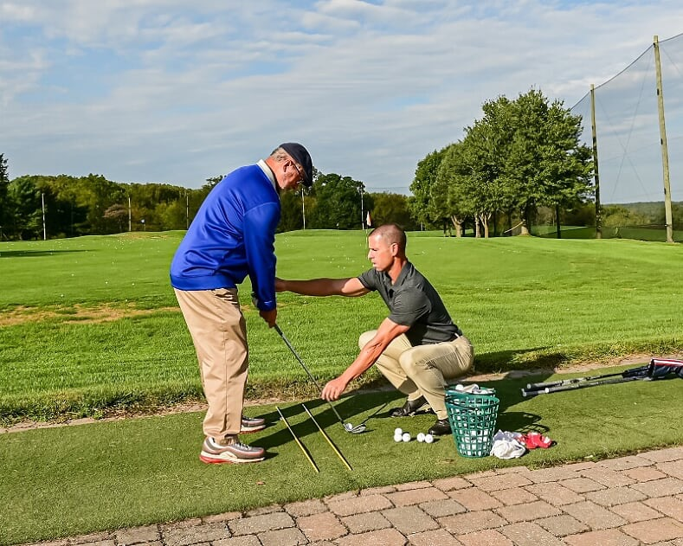

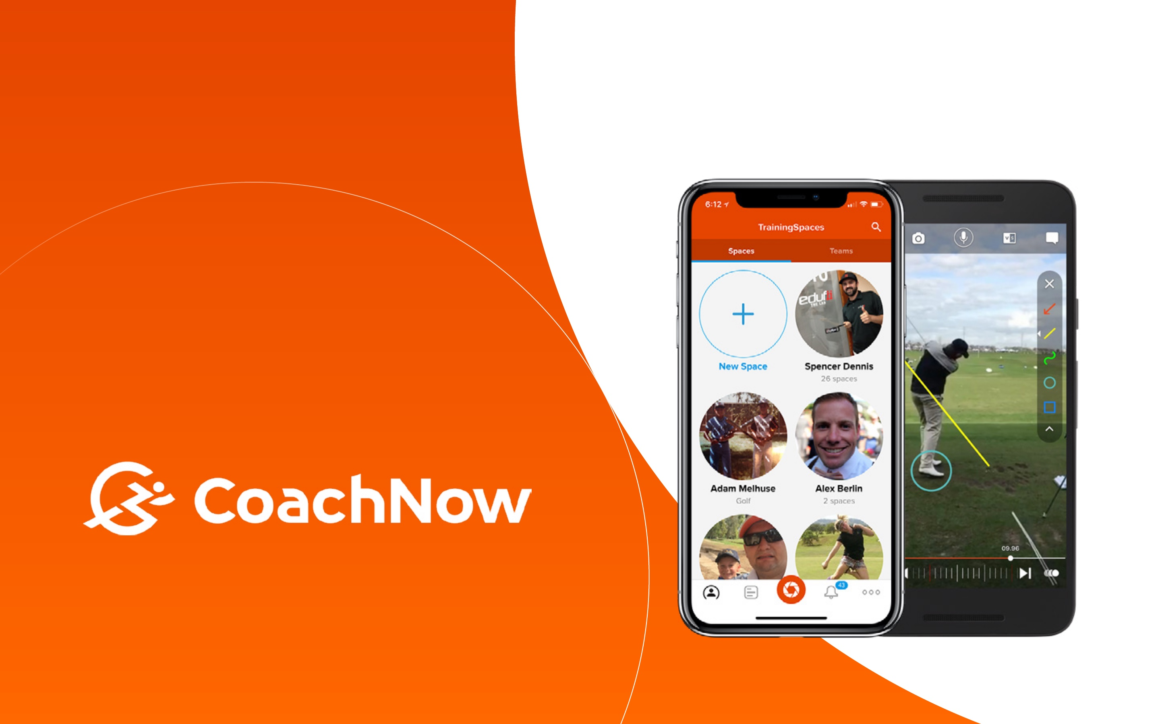
Get Golf Ready - Beginner Series
Aimed at introducing the game in a fast, fun and affordable way, this 4 week series targets adults with little or no experience and will cover all of golf’s basics, including full swing, short game, a background of its rules, and course etiquette - all in an enjoyable, small group environment. Clinics will take place on the following Tuesdays/Thursdays from 6:00pm until 7:00pm and run for 4 weeks (golf clubs will be provided to those in need).

Session 1 – April 4th, April 11th, April 18th, April 25th
Session 2 – June 6th, June 13th, June 20th, June 27th
Session 3 – July 9th, July 16th, July 23rd, July 30th
Session 4 – August 8th, August 15th, August 22nd, August 29th
Session 5 - September 5th, September 12th, September 19th, September 26th

Week 1: Full Swing (irons)
Week 2: Short Game (chipping and pitching)
Week 3: Full Swing (driver and fairway woods)
Week 4: Putting

COST: $175 per 4 week session

Ladies 30 & 3 Program
Catered toward the beginner and intermediate player, this program will entail a 30 minute instructional clinic followed by 3 holes of golf in a fun and stress free setting! Clinic topics will vary, covering the full swing and short game, and complimentary wine will be served prior. Sessions will be held from May through October on the following Wednesdays (golf clubs will be provided to those in need).

May 15th, May 29th (6:30-8pm)
June 5th, June 19th, June 26th (6:30-8pm)
July 10th, July 24th (6:30-8pm)
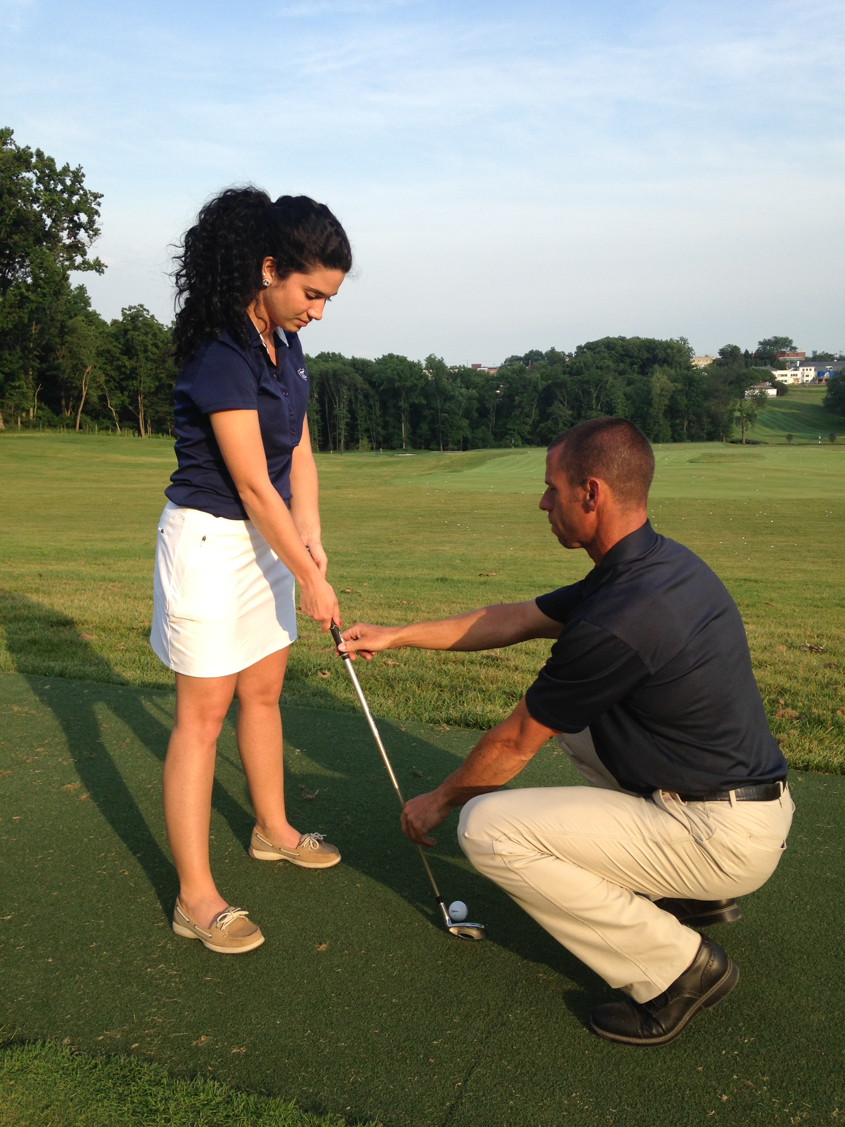
August 7th, August 21st (6:30-8pm)
September 4th, September 18th, September 25th (5:45-7:15pm)
October 2nd, October 9th, October 16th (5-6:30pm)

COST: $65 per student per session

‘Bring Your Own Group’ Lessons
Do you have friends or partners that want to get into golf or are interested in improving their game? Our ‘Bring Your Own Group’ option allows you to form your own group lesson. These clinics may be customized for each group based on specific interests and skill levels. A minimum of 3 people is required. Lessons may be scheduled at the convenience of the group.

COST: $40 per student per session

On Course Playing Lessons
From tee to green, Ryan will assist you with course management and strategies that will help you get the most out of your game (please speak to or email Ryan @rkempski@deerfieldgolfclub.com prior to booking).

COST: $175 per 9 holes ($75 Additional Student)

Online Lessons
If you’re unable to work with Ryan in person, join him remotely for this next best option. Interested students simply need to share two swing videos from face on and down the target line views. These can be taken indoors or outdoors from home, preferably while hitting a ball of some sort (foam, wiffle, actual), or of course from a practice range or golf course. Ryan will follow up with a voice over video and swing critique, as well as provide helpful drills that can be performed at home, the range, or golf course. Please email Ryan @rkempski@deerfieldgolfclub.com prior to booking for clarification on swing video exchanges and payment protocol.

Single Swing Evaluation: $50
Unlimited Month of Instruction: $120

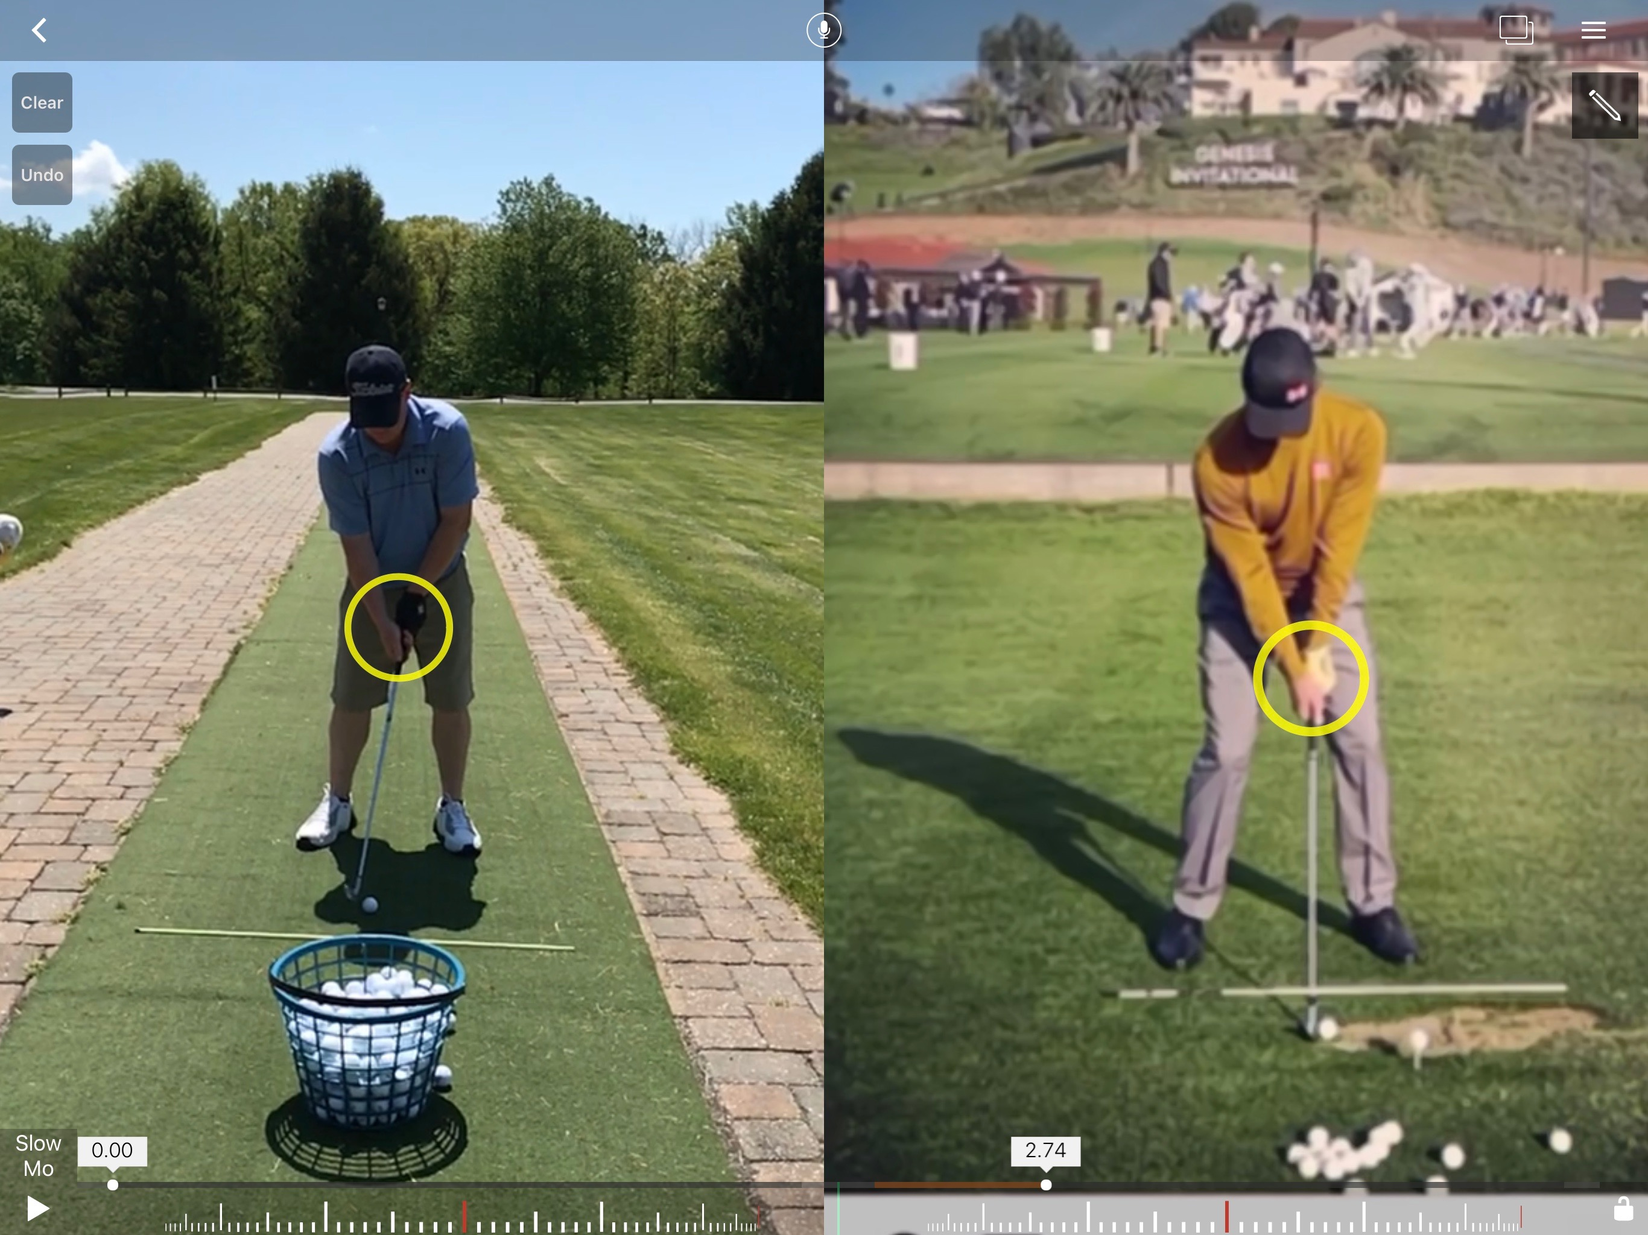
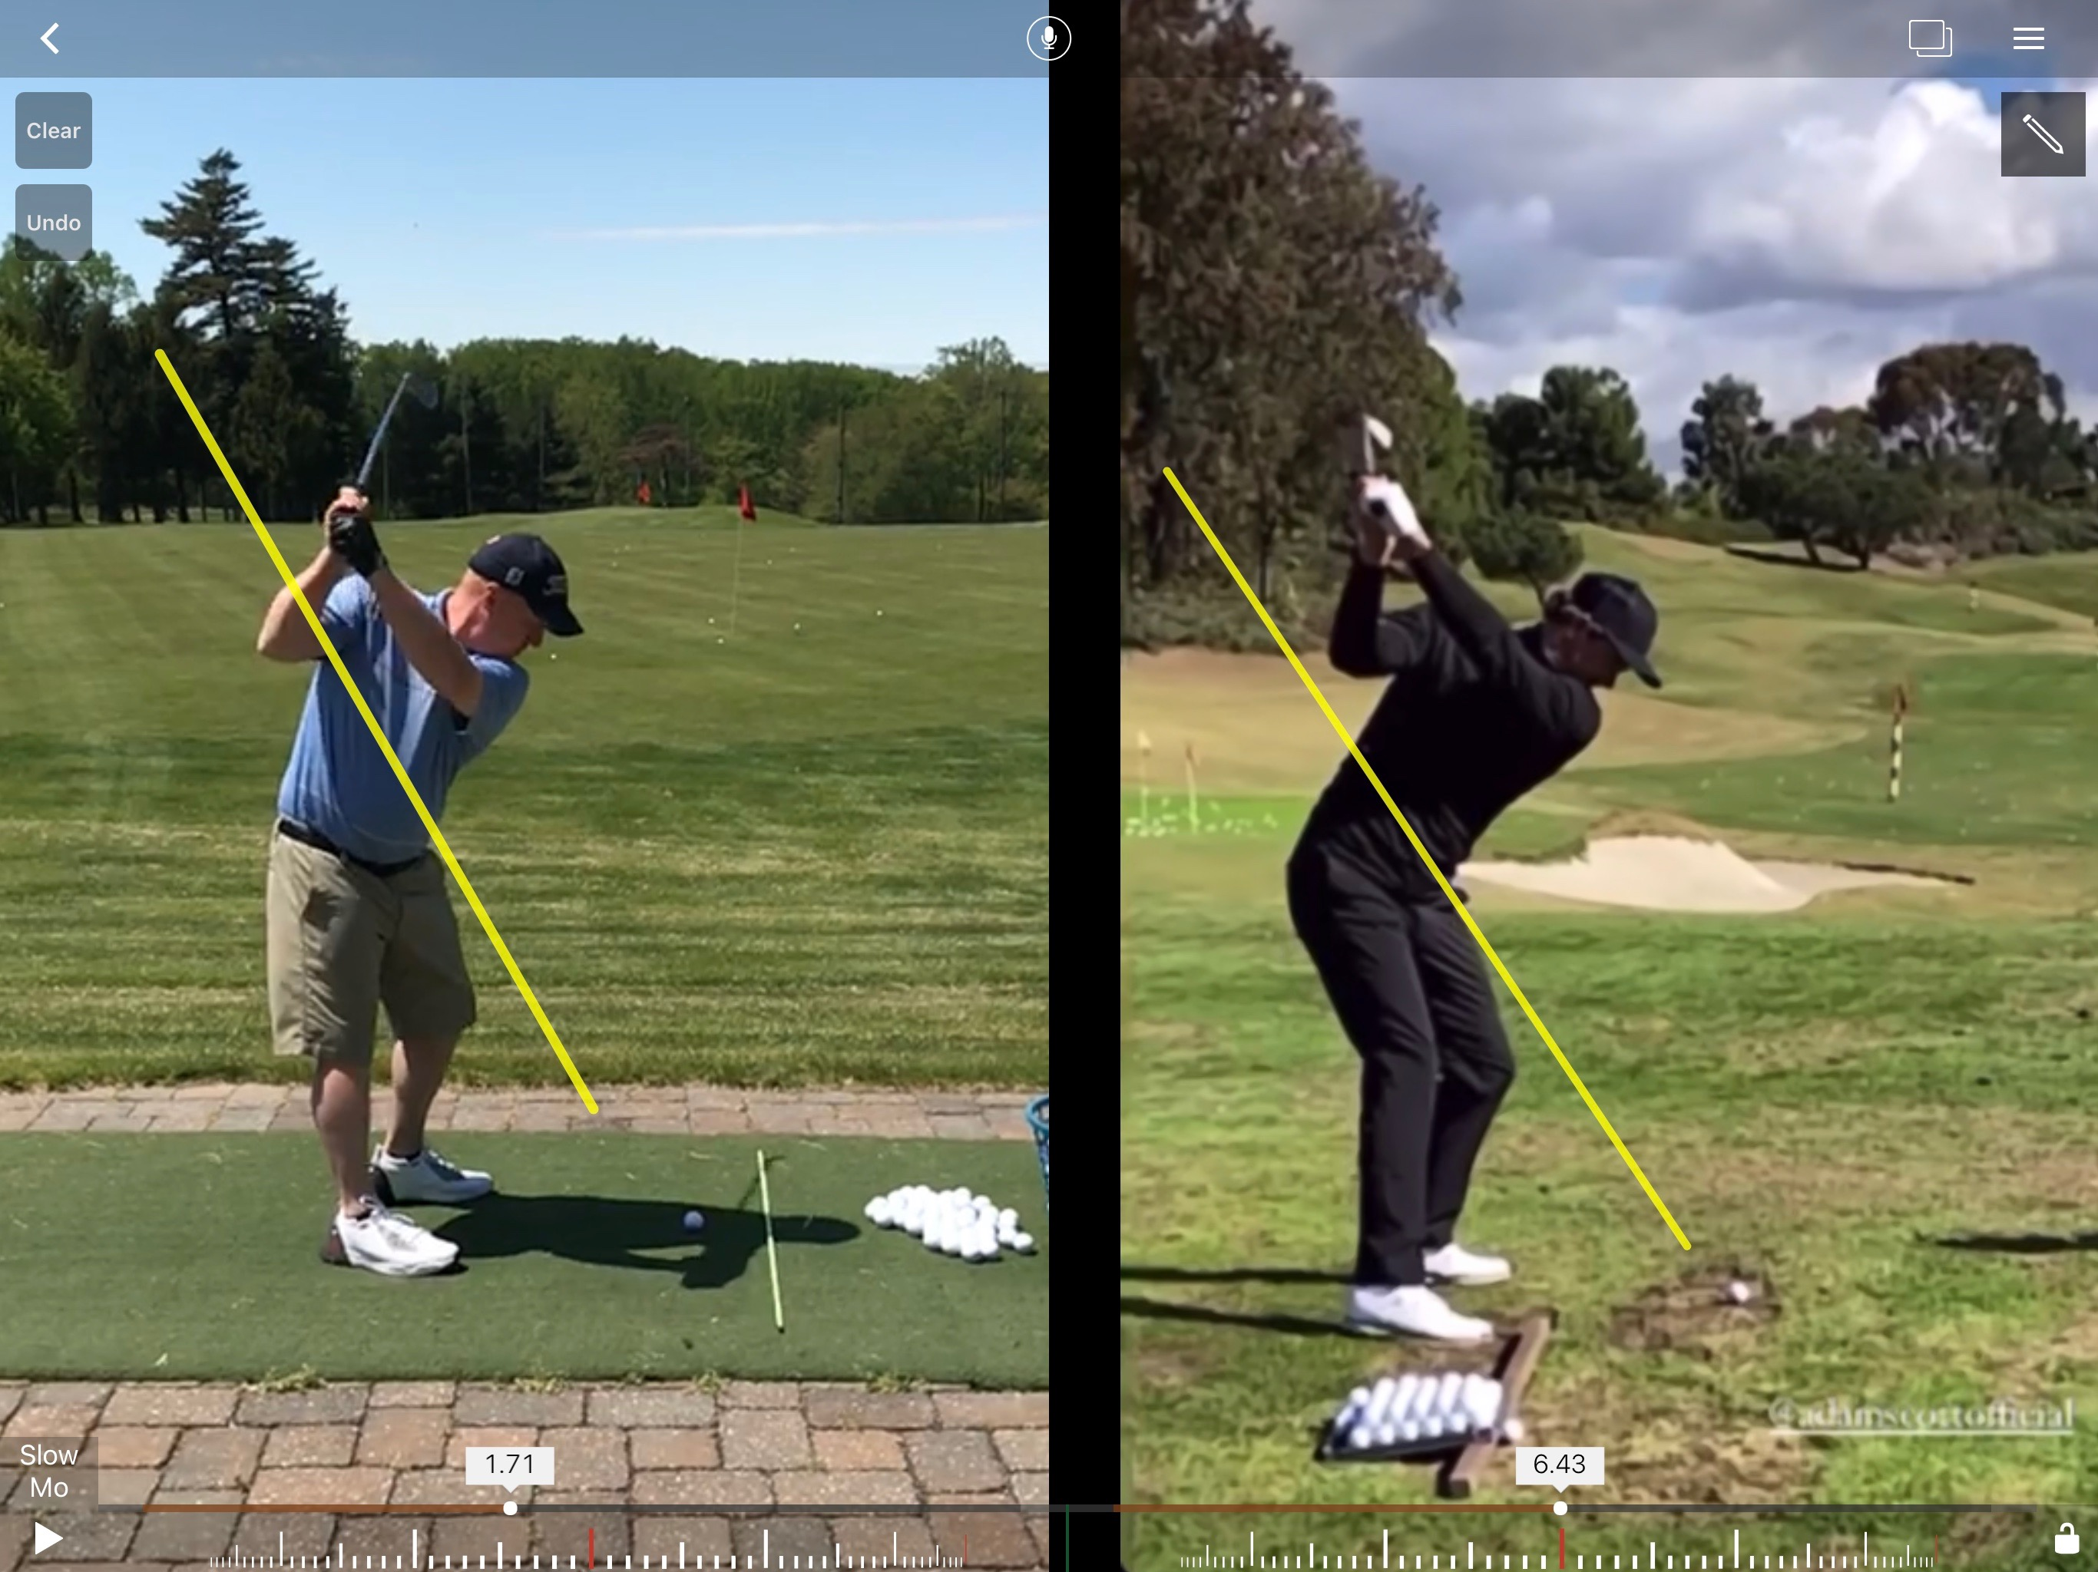

BOOK ONLINE HERE: https://clients.uschedule.com/deerfieldgolfclub/booking

