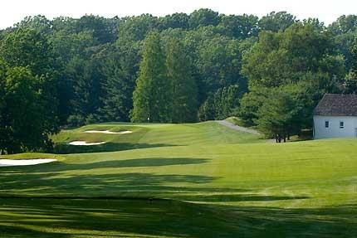

The Deerfield Golf Academy is pleased to provide the region’s most well-known and respected golf instructors to guide your junior golfer toward having more fun and being a better player. Regardless of age, gender or ability level, you can be confident that Deerfield’s Director of Instruction Ryan Kempski will make learning golf fun and exciting. If you are uncertain as to which program might benefit your junior golfer most, give us a call and we’ll gladly make any recommendations.

Private Lesson Rates (under 18 years of age)
Private Lesson: $90 per hour / $50 per half hour
Additional Students: $25 per student per hour
Monthly Series (4 one-hour lessons per month): $320 (individual)/$420 (2 juniors)

‘Bring Your Own Group’ Lessons
Do you have children, relatives and/or friends of either that want to get into golf or are interested in improving their game? Our ‘Bring your Own Group’ option allows you to form your own group lesson. These lessons will be customized based on the group’s interest and skill level. A minimum of 3 students is required. Lessons may be scheduled at the convenience of the group.

COST: $35 per student per lesson
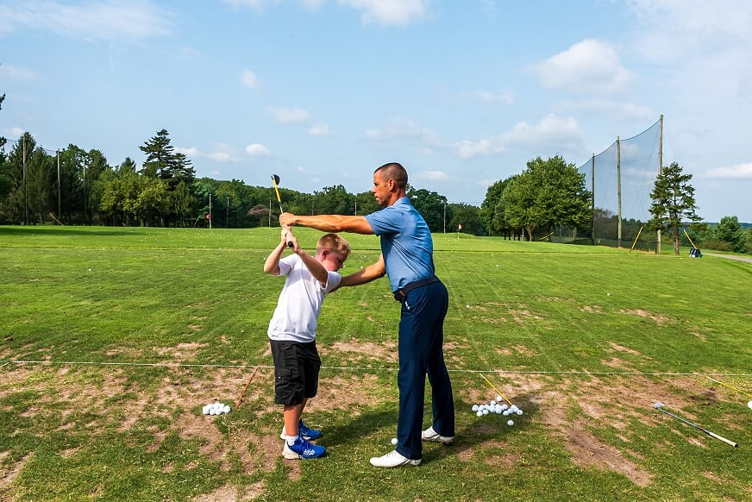
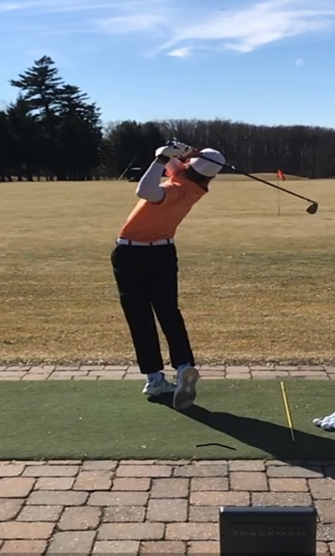

Junior Summer Day Programs
Deerfield’s Junior Development Summer Day Programs are designed for boys and girls of all skill levels between the ages of 8 and 17. Every aspect of golf will be covered, from etiquette and technique to care of the golf course. Juniors will learn on one of the finest classrooms in the country, the first-class practice facilities at Deerfield and its William Gordon designed championship golf course. All programs will take place from 9:00am-12:00pm on the following dates (please specify which session you prefer when calling).

Session 1: June 10th – June 14th
Session 2: June 17th – June 21st
Session 3: July 8th – July 12th
Session 4: July 22nd – July 26th
Session 5: August 12th – August 16th

Cost: $299 per student per session
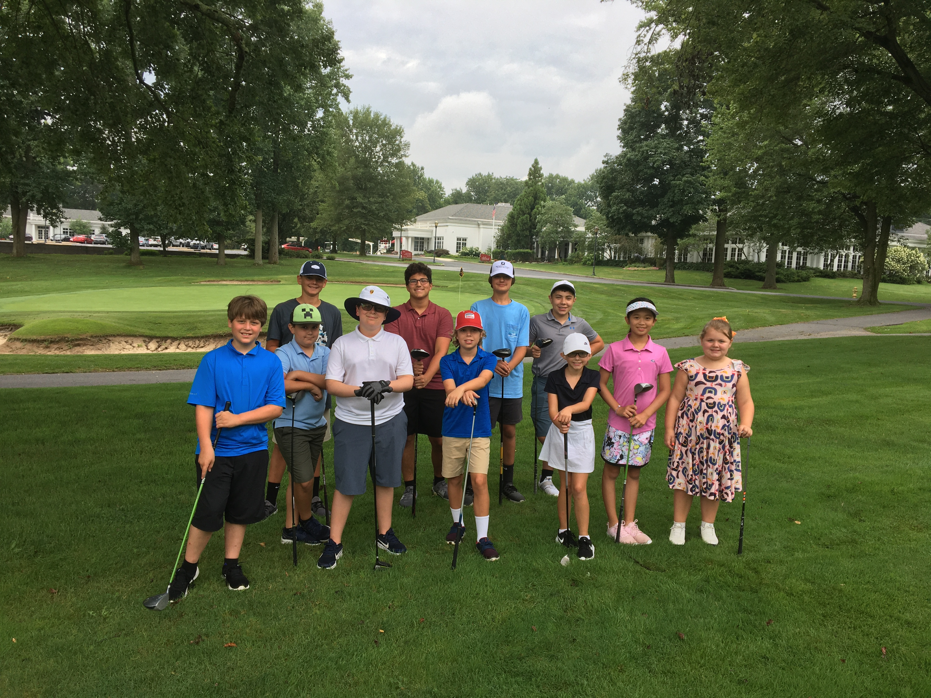

Note: Due to limited space, full payment is required to confirm your reservation. Payment can be made by credit card over the phone or by check. Please make checks payable to Deerfield and send along with the completed/signed release form (we will provide) to:
Deerfield Golf Academy, 507 Thompson Station Road, Newark, DE 19711

BOOK ONLINE HERE: https://clients.uschedule.com/deerfieldgolfclub/booking

