2024 ADULT LESSONS, CAMPS AND CLINICS
WITH MICHAEL TOBIASON

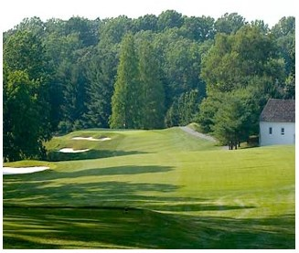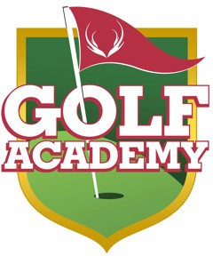

The Deerfield Golf Academy is pleased to provide the region’s most well-known and well respected golf instructors to guide you toward having more fun and being a better player. Whether it’s an individual lesson, a series of lessons, a specialty camp or a group clinic, Head Golf Professional Michael Tobiason, Jr. will design a program of instruction that suits your needs. To book your lessons with Michael, please call the Proshop at 302-368-6640 x 3.
Private Lesson Rates
Michael Tobiason
Private Lesson: $115 per hour / $65 per half hour
Passholder Rate: $105 per hour / $60 per half hour
Three Hour Series: $320 (All series must be completed by December 31, 2024)
Three Hour Passholder Series: $295
Additional Students: $40 per student per hour
Private Group Lessons available – Ask for details

‘Bring Your Own Group’ Lessons
Michael Tobiason
Do you have friends or partners that want to get into golf or are interested in improving their game? ‘Bring Your Own Group’ Lessons allow you to form your own group lesson. This class will be customized for each group based on their interest and skill level. A minimum of 3 people is required. Classes may be scheduled at the convenience of the group.
COST: $40 per student per session
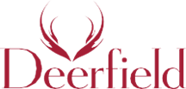
On Course Playing Lessons
Michael Tobiason
Come play alongside Big Break Contestant and 2011 US Open Participant Michael Tobiason. From tee to green, Michael will help assess your strategies and improve your weaknesses to help you get the most out of your game.
COST: $200 per 9 holes including greens fees ($30 Additional Student)

302-368-6640 | 507 Thompson Station Rd, Newark, DE 19711 | DeerfieldGolfClub.com

