2024 JUNIOR LESSONS,
SUMMER PROGRAMS AND CLINICS
WITH MICHAEL TOBIASON

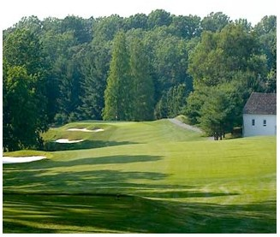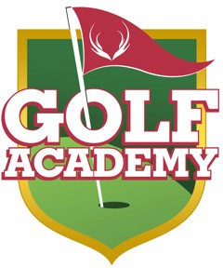

The Deerfield Golf Academy is pleased to provide the region’s most well-known and well respected golf instructors to guide your junior golfer toward having more fun and being a better player. Regardless of age, gender or ability level, you can be confident that Deerfield’s Head Golf Professional Michael Tobiason, Jr. will make learning golf fun and exciting. If you are uncertain as to which program might benefit your junior golfer most, give us a call and we’ll gladly make some recommendations. For lessons with Michael, please call the Proshop at 302-368-6640 x 3.
Private Lesson Rates (under 18 years of age)
Michael Tobiason
Private Lesson: $90 per hour / $50 per half hour
Additional Students: $25 per student per hour
Private Group Lessons available – Ask us for details

Junior Summer Day Programs
Deerfield’s Junior Development Summer Programs are designed for juniors of all skill levels. Every aspect of golf is covered, from etiquette and technique to care of the golf course. Guests will learn on one of the finest classrooms in the country, the first class practice facilities at Deerfield and its William Gordon designed championship golf course.

Junior Half Day Instructional Program is designed for boys and girls ages 8 to 17. All programs are from 9:00am-12:00noon. Please specify which session you prefer when calling.

Session 1: June 10th – June 14th
Session 2: June 17th – June 21st
Session 3: July 8th – July 12th
Session 4: July 22nd – July 26th
Session 5: August 12th – August 16th
Cost: $299 per student

Note: Reservations required for junior camp participants. Please visit the link below or scan the QR code to sign up today!

https://clients.uschedule.com/deerfieldgolfclub/booking/event/eventdates/29526

“Make Your Own Group” Lessons - $35 per student per lesson
Michael Tobiason
Do you have friends or partners that want to get into golf or are interested in improving their game? “Bring your Own Group” Lessons allow you to form your own group lesson. This glass will be customized for each group based on their interest and skill level. A minimum of 3 people is required. Classes may be scheduled at your convenience.

302-368-6640 | 507 Thompson Station Rd, Newark, DE 19711 | DeerfieldGolfClub.com 